A Macinante Australia Publication http://macinante.com Tel Graham (02) 9520-6042

Macinante News

Volume 10 Issue 1 March 2011
FAMILY HAPPENINGS KEEPING in touch

Macinante Web Site
Mick Macinante continually updates the Macinante Web site (http://macinante.com) with family happenings and events. If you have any items that you feel you would like to have included on the web site, send them to Michael on mickmac@sydney.dialix.com.au GB
2011 Family Picnic
Once again we will hold the Family Picnic at Bankstown Sports Club. Even though the number of Macinante descendants attending is far fewer than in the past we have determined to continue whilst at least some enjoy catching up with family members. GB

Deaths
2010 presented itself as a tragic year for Macinante family
Anastasia Cuddy 25.8.10 was one of the stalwarts of the Macinante Family. She never missed a family gathering and encouraged her family to attend.
Melissa Cuddy 5.6.10 (Anastasia’s Twin Granddaughter) was a sudden and shocking loss at the tender age of 40.
Marianne Beatson 6.12.10 died suddenly in St George Hospital of a heart attack after many years of Kidney Dialysis. Marianne rarely missed a Macinante Picnic.
Eugenio Grimaldi husband of Nina died on the 14th August 2010.
June Onorato, wife of Victor died in September 2010

Musical Macinante’s
- Sisters Caitlin and Brianna Macinante daughters of MP for Robertson - Deborah O’Neill sing at their first gig at Grumpy’s Bar and Grill Terrigal on January 4, 2010. They are great granddaughters of Johnny and Rose Macinante.
Family Reunion
Highlights in This Issue
1 | Macinante Web Site
2 | 2011 Family Picnic
3 | Deaths
4 | Musical Macinante’s
5 | Family Reunion Maria, Kay, Nell and Lynne
6 | Sr Irene in East Timor
7 | Port Macquarie Reunion with Lynne & Barry Hails
8 | Births
9 | Kerry and Gary Hamer in outback Australia
When in Sydney on the weekend with Maria & Len we went to State Theatre to see Patrizio Buanne (Italian Singer) and he was very good.
We caught up with Nell Flemming (nee Macinante) in Mittagong. Nell and mum (Anne Sambuco) spent a lot of time together as youngsters. We had a lovely day with Nell. She sure looks good for 87. She cooked us a beautiful, typical Italian Dinner. Kay Holst
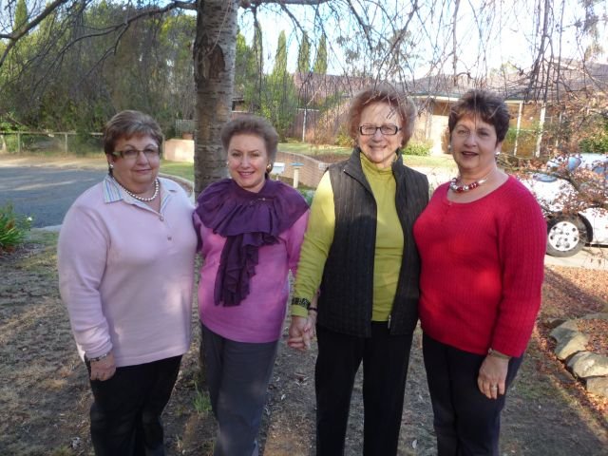
Photo – Maria, Kay Holst, Delizia (Nell) Flemming and Lynne

Sr Irene Macinante in East Timor
Sister Irene Macinante, great granddaughter of our family patriarch and matriarch, Salvatore and Anastasia Macinante, works educating and encouraging local teachers leading young East Timorese children at the start of their lives. Salvatore and Anastasia's great grandson and great great grandson, Gerard Macinante and Luke Macinante helped construct a school at Oetapó. As well as applying their construction skills they used a talent that Macinante's in all branches of the family talk about which is improvisation. How do you lay a slab when there are no ready made concrete providers?

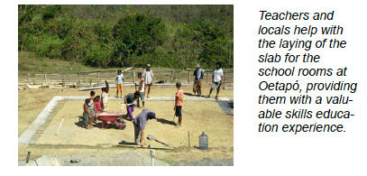

Port Macquarie
Back in 2003 Kath & Mick (Michael) Macinante met for the first time and holidayed in Italy with Macinante cousins Lynne & Barry Hails (Lynne is granddaughter of Edmondo and Mick is grandson of Candido).
While Kath & Mick were on holidays in April 2010 both couples met for the first time since 2003 in Lynne & Barry's home town of Port Macquarie and reminisced about their 2003 Italian tour, their Macinante ancestors and other overseas holidays each couple has enjoyed since. MM
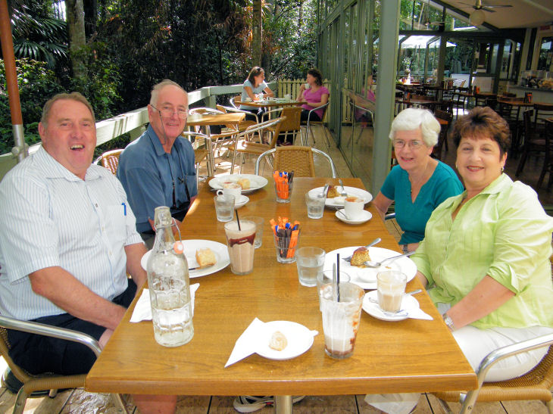
Barry Hails, Michael Macinante (Candido's grandson), Kath Macinante and Lynne Hails (Edmondo's granddaughter) at Sea Acres, Port Macquarie. April 2010 MM
______________________________________________
Births
Lynn and Barry Hails have another granddaughter Mackenzie Jean born 3 May 2010 to son Brett & wife Kirsty. Sister for Lleyton, (Maclean deceased) Braedon & Lachlan – they are thrilled to have a daughter. LH

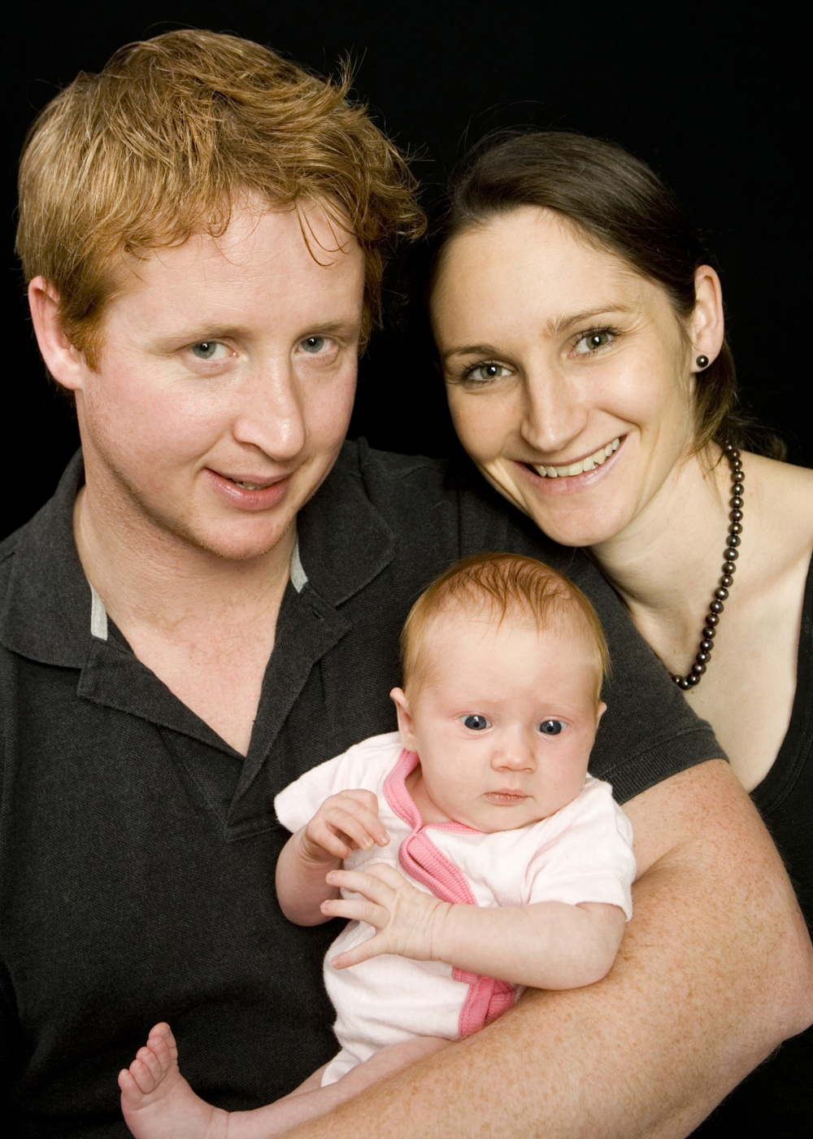

Proud parents Jason Greenall and Fiona Macinante welcomed Madelyn Oni Greenall into the world on 02 August 2010." FM

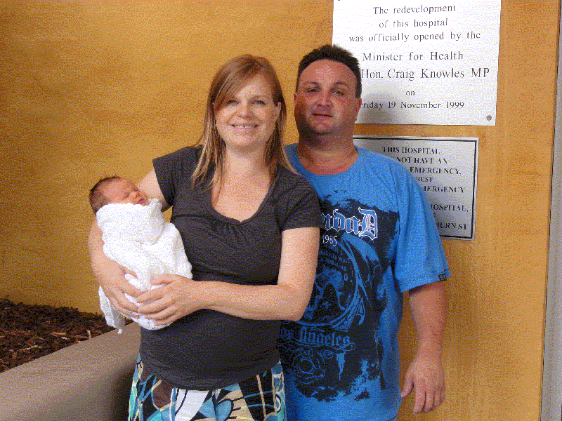
Kylie and Shane Beatson celebrated the birth of their third child Isabel Maree on the 11th February 2011. Iszabel has an elder sister Olivia and brother Joel. GB

_____________________________________________

Balgo - Kutjunka Region
Kerri Hamer, great granddaughter of our family patriarch and matriarch, Salvatore and Anastasia Macinante, and husband Gary, spent the year 2010 in a town called Balgo in Western Australia about 200Km west of Alice Springs teaching Aboriginal children.. GB
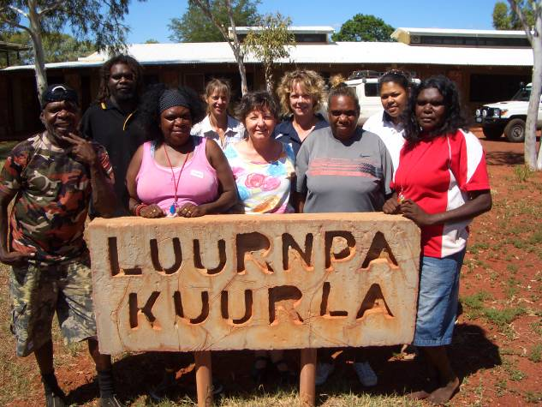
Kerry with aboriginal assistant teachers
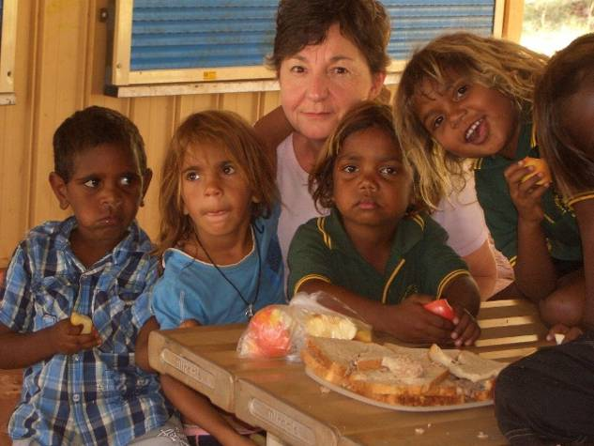
Kerry with aboriginal children at lunch
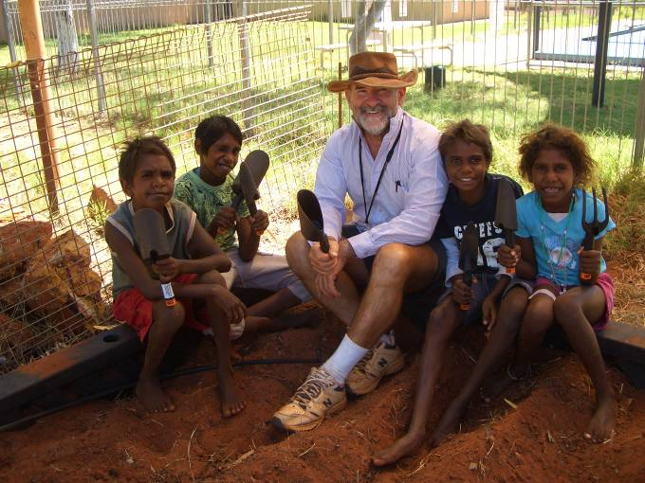
End of term 1 - Gary and some children preparing a garden bed for seed planting. Every session starts with a safety warning about tools and bare feet.

