A Macinante Australia Publication http://macinante.com Tel Graham 9520-6042

Macinante News

Volume 9 Issue 1 March 2010
FAMILY HAPPENINGS KEEPING in touch

Macinante Web Site
Mick Macinante continually updates the Macinante Web site (http://macinante.com) with family happenings and events. If you have any items that you feel you would like to have included on the web site, send them to Michael on mickmac@sydney.dialix.com.au GB
2010 Family Picnic
The family gathering at the Bankstown Sports Club proved to be a success with those who attended pleased with the change in venue. As such, the 2010 family day will be the second gathering held at this venue. At least we do not have to worry about the weather, flies and a lot of picnic packing on the day. GB

England, Ireland and France
In 2009 Kath & Mick Macinante together with four others went on a self organised tour of England, Ireland and France.

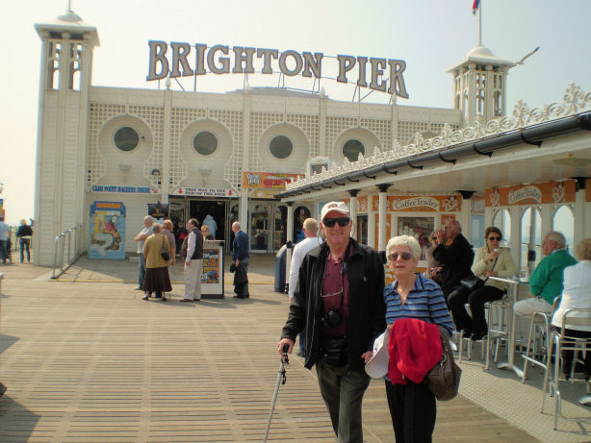
Mick and Kath at Brighton Beach

Highlights in This Issue

1 | Macinante Web Site
2 | 2010 Macinante Picnic
3 | England, Ireland and France
4 | A Star is Born
5 | Births
6 | Out Back Australia

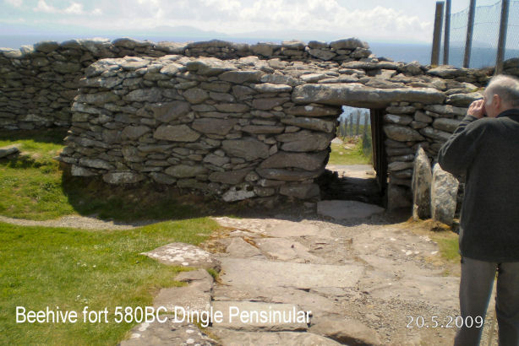
A highlight of England was a Macinante cousin’s reunion in London with Greg and Mary Holloway. They visited many castles, Roman and Viking things and of course had to experience some of England's Heritage Railways like the Bell Bird, the Bodmin & Wenford and the East Lancashire Railways. A ride in a canal long boat was a must do.

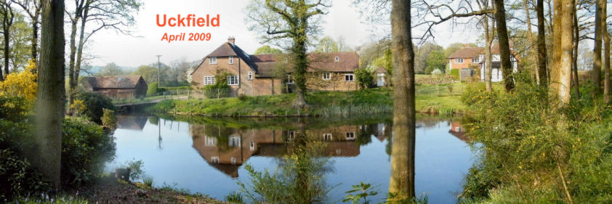

In Ireland they went to many castles, and had a peat fire to warm themselves. Water puddles everywhere made Ireland look very green. A Heritage railway had a monorail which once was 120 miles long and dated back to 1888. Belfast showed the development delay caused by their "troubles" e.g., the suburban railway is not yet electrified.
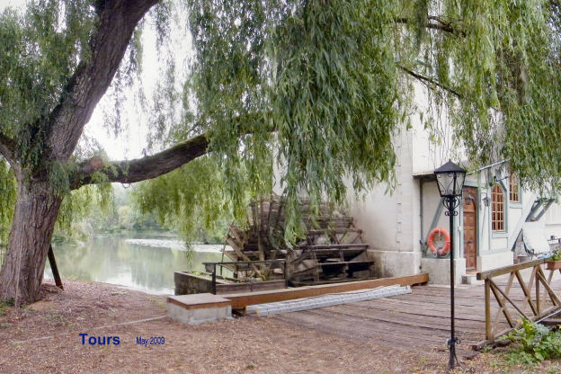

In France they stayed near Tours on a property which had the remains of a water wheel operated mill which might have been similar to Fosso Macinante (which translates to little Mill) in Florence, Italy. They travelled to Paris, their last holiday destination, on a High Speed Train.
In all countries they stayed out of town and cities where possible so they could experience the country's real life. MM
______________________________________
A Star is Born
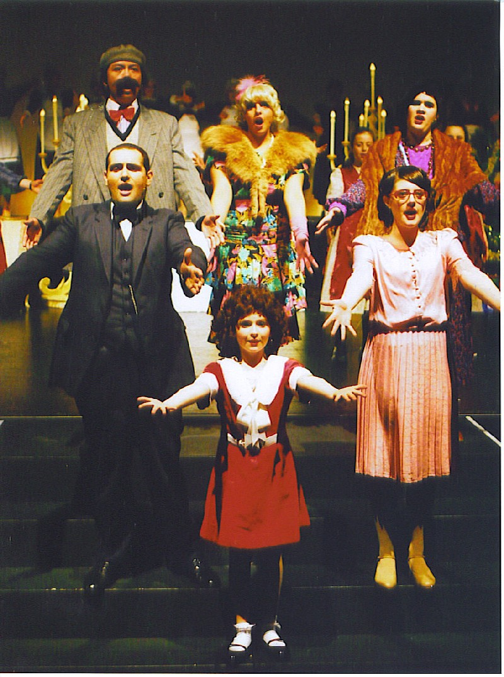
Lauren in the finale of ANNIE

In September 2009 Candido Macinante’s great, great granddaughter Lauren Beatson starred in the South Eastern Musicals presentation of “ANNIE”. She was musically directed by “Little Patti” and received the highest of accolades. Little Pattie presented Lauren with an excellent reference in view of her outstanding singing, dancing and acting abilities. GB
______________________________________________
Births
Ann Cuddy (Daughter of Candido Macinante) has a new great granddaughter Elora Danin Ainsworth born on the 3 September 2009. Elora is the daughter of Scott and Jacki Ainsworth of Ingleburn. Scott’s mother is Cecilia Ainsworth (nee Cuddy)
Ann Cuddy also has a new great granddaughter Rhiannon Leslie Cuddy to Mark and Debbie Cuddy born on the
10 April 2009. AC
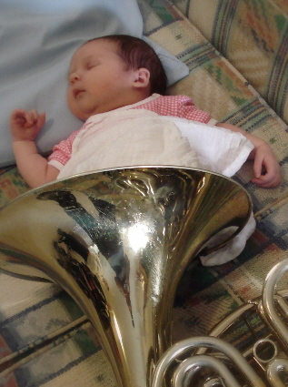
Lucy Olivia and the family French Horn

Tory Macinante’s Daughter Mollie-ann is now a first time grandmother to Lucy Olivia Hallam. Lucy was born to French Horn players Joan and Adrian Hallam. She was born at Royal Hospital for Women in Randwick at 9.52pm on 6 October 2009 and weighed 4.515kg. JT
_____________________________________________

Outback Australia
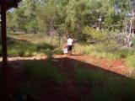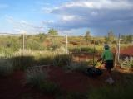
Kerri walks 1 minute to work whilst Gary mows the lawns outside their “Donger”.

Joe Macinante’s daughter Kerri Hamer and her husband Gary have gone bush for 2010. They have left their respective jobs and are now living and working in Central Australia at Bulgo. Kerri is teaching at the school where there are 10 white staff members and 8 aboriginal assistants with 80 enrolled students. Gary is the pool life guard and manages the pool from 11.45am to 2.00pm. He also picks up the food for the school canteen and works behind the scenes doing odd jobs. KH

