A Macinante Australia Publication http://macinante.com Tel Graham 9520-6042

Macinante News

Volume 8 Issue 1 March 2009
FAMILY HAPPENINGS KEEPING in touch

Macinante Web Site
Mick Macinante continually updates the Macinante Web site (http://macinante.com) with family happenings and events. If you have any items that you feel you would like to have included on the web site, send them to Michael on mickmac@sydney.dialix.com.au GB
First Son of Shane and Kylie
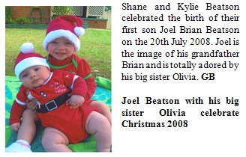
2009 Family Picnic
The Macinante Picnic has taken a new direction in 2009. It will be held at the Bankstown Sports Club, Greenfield Station Bistro. Several family members have suggested the change of style and venue. If the change proves to be successful we will continue this theme into the future GB

Family Loses
During 2008 we lost three of our valued family members. Maria Macinante 9.8.2008, Bianca Macinante 17.8.2008 and Nestina Senti 5.11.2008. These great ambassadors who contributed so much to the family and our great country will be surely missed by all whom new and adored them. GB
Wedding Bells.

Highlights in This Issue

1 | Macinante Web Site
2 | First Son of Shane and Kylie
3 | Family Loses
4 | 2009 Family Picnic
5 | Wedding Bells – David and Narith Carter
6 | Snake Hunting in India
7 | Newlyweds – Peter and Judith Pallanza
8 | Newlyweds Kelli-ann Dugdale and Clint Leckie
9 | Ann Cuddy - Named In Honor
Narith and David on their Australian wedding Day at 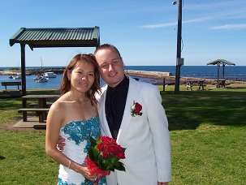
Shellharbour.

David Carter made absolutely sure that he was well and truly married after two wedding ceremonies to the same girl. David married Narith Ty in a lavish six day Cambodian wedding and then on the 19th August 2008 tied the knot once more in a much less extravagant Aussie wedding overlooking the ocean at Shellharbour marina followed with a wedding luncheon at the local Shellharbour Chinese restaurant. They have settled in Oak Flats where David is building a photographic and framing business and Narith works in her families business - Oak Flats Central Café. GB

Snake Hunting in India
In June 2008 Daniel Holloway, son of Greg and Mary, joined 15 others on a 10-day holiday travelling through India’s Western Ghats mountains (near Goa) in the monsoon season.
Over the next few days they hiked through jungle and mountains in the pouring rain. They walked through rivers and mud up past their knees. They found several animals including monkeys, a type of tree-dwelling bear, Indian Cobras, Malabar Pit Vipers (a tree-dwelling relative of the rattlesnake named for the heat-sensing pits in the face), giant praying mantis and a scorpion as long as your hand. They bagged them (not the monkeys!) and took them back to camp where they photographed them before releasing them.
Here is a photo of Daniel with one of his specimens. He is wearing a scarf to help keep the leeches away. GH

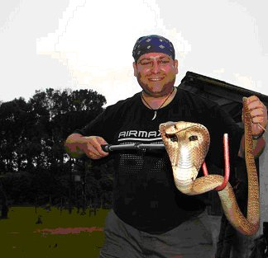
Daniel Holloway showing his snake handling skills with one of his prized catches.

Newlyweds – Peter and Judith Pallanza 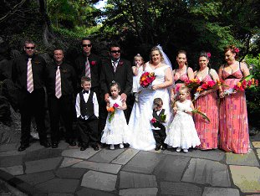
The wedding party looked a picture with the three bridesmaids, groomsmen and children.

On the day of the 2008 family picnic, Peter and Marilyn Pallanza attended the wedding of their only son Anthony.
Brides name: Judith Lampard (Now Pallanza)
Wedding Date: 1st March 2008
Ceremony: Auburn Japanese Gardens
Reception: Revesby Heights ex Serviceman’s Club
Honeymoon: Fiji for one week leaving on Monday the 5th of May 2008.
All of their children Jasmyn, Jacinta and Harrison were participants in the wedding and looked fantastic.

Newlyweds Kelli-ann Dugdale and Clint Leckie
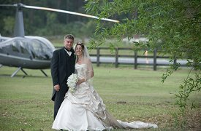
Kelli-ann Dugdale married Clint Leckie in January at Anuuka Resort, Coffs Harbour. Clint is an accountant for Nambucca Council and Kelli-ann is a solicitor in Coffs Harbour. After a honeymoon at Couran Cove Resort they settled into their new home in Boambee (near Sawtell). Kelli-ann is Maria Carniato’s youngest daughter.
Leah and Gavin Shepherd welcomed their third child, daughter Ava last year. A sister for Isabella and Jye. Maria is the eldest daughter of Maria Carniato who is the daughter of Norman Macinante. Leah lives in Gumma near Macksville,NSW.
Mark Gentle married Stephanie Thompson in November 2007 with the harbour as the back drop. They had a belated honeymoon over the Christmas holidays in Europe. Stephanie is a teacher at Pymble Ladies College. They live in Gymea. Mark is the son of Joan and Derek Gentle. Joan is Norman Macinante’s youngest daughter
Ann Cuddy - Named in Honor
Anastasia Cuddy was honored in 2008. Her grand-daughter, Genevieve Cuddy made arrangements for a new variety of Rose to be named in her honor. Ann Cuddy is a keen gardener and a great lover of roses. She is a member of Swane’s and purchases roses from Swane’s at Dural. Ann commemorates the loss of loved ones by planting a rose in their honor. Adjacent to her front door are her two brothers Tory and Joe, Husband Rowe and life long friend - Winfred Masters.  The Anastasia Cuddy Rose is a beautiful pale lilac colour with a lovely soft scent. A number of Macinante Family Members obtained plants and had their first blooms in the 2008 season | 

