A Macinante Australia Publication http://macinante.com Tel Graham 9520-6042

Macinante News

Volume 7 Issue 2 May 2008
FAMILY HAPPENINGS KEEPING in touch

Macinante Web Site
On the Macinante Web site is every past edition of the Macinante News and photos from all picnics back to 1981. All you need to do is to type into your browser address box “macinante.com”
MM
Baby for Leah
Leah Shepherd with baby Ava who was born on 3rd October 2007.
Leah is the daughter of Maria Carniato and granddaughter of Norman and Mary Macinante. Ava is the third child of Leah and Gavin Shepherd. She is sister to Isabella 6 and Jye 3. Isabella was born on 13th November 2001and Jye on the 10th May 2004. Leah and Gavin married in September 1999. LS

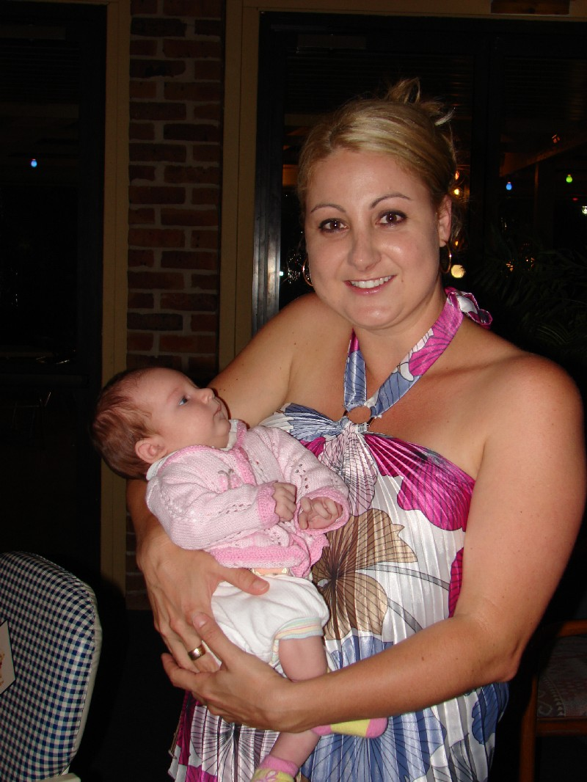

Leah holding baby Ava.
Norman’s 80th Birthday
Norman Macinante has reached the ripe age of 80 on the 30th November 2007. He may now be considered the godfather of his branch of the Macinante tree with Mary’s approval of course. Norman celebrated his birthday with family and friends at Boambee Bay resort. GB

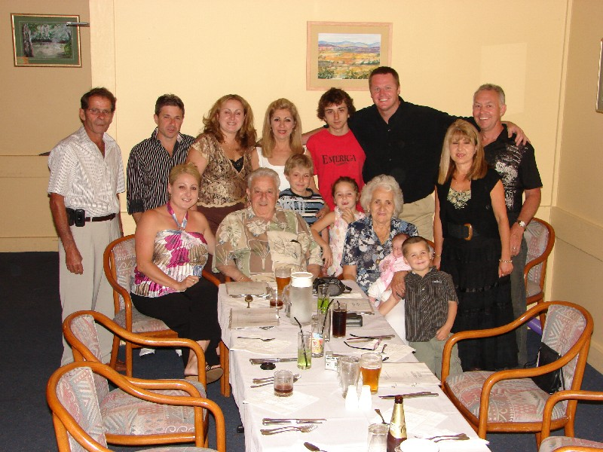

Norman Macinante celebrated his 80th Birthday with family at Boambee Bay Resort.

2008 Family Picnic
Thirty Four descendants enjoyed the 2008 annual family picnic. The weather was kind, not too hot or too cold. Photographs may be viewed on the web site. GB

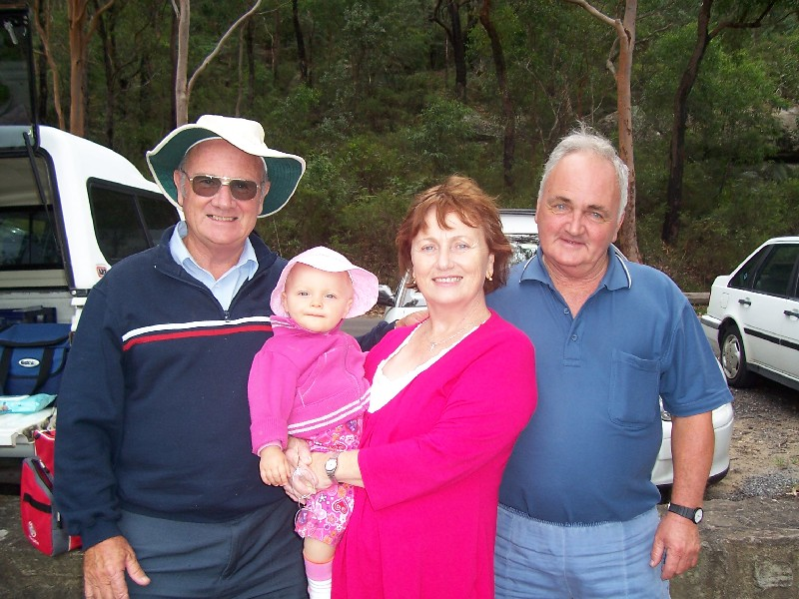

Highlights in This Issue

1 | Macinante WEB Site
2 | Baby for Leah
3 | Norman’s 80th Birthday
4 | 2008 Family Picnic
5 | Wedding Bells – Mark and Stephanie Gentle
6 | Newlyweds – Joan and Adrian Hallam

Graham, Olivia, Margaret and Brian enjoyed the Macinante picnic with their extended family.

Wedding Bells.
Mark Gentle and Stephanie Thompson were married on 16th November 2007. Everything was absolutely perfect, weather, people and venue.
Mark is the son of Joan (Giovanna) and Derek Gentle. Joan is the daughter of Norman (Nicola) and Mary (Maria) Macinante with Norm’s father Edmondo one of the original Macinante immigrants to our shores. DG

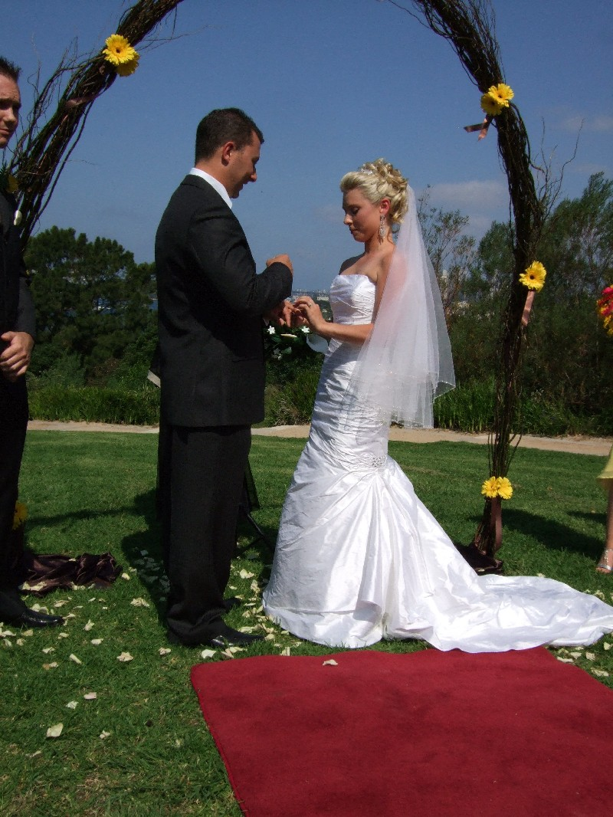

Mark and Stephanie Gentle exchange Wedding Vows.

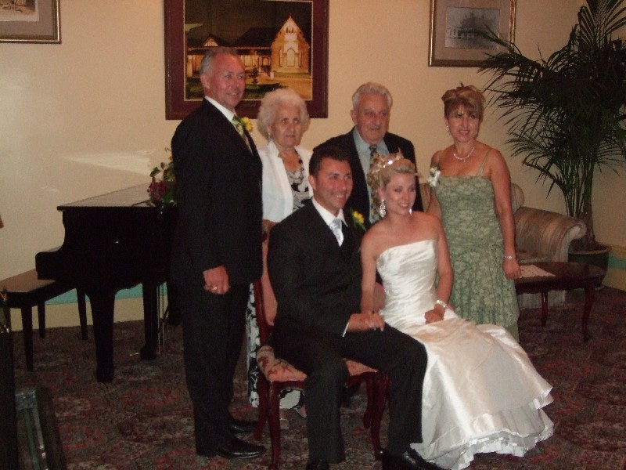

Mark and Stephanie Gentle with Mark’s Mum and Dad and Grandparents

Newlyweds – Joan and Adrian Hallam
We were engaged on the 4th of February 2007 whilst sailing away from Bora Bora, Tahiti, at sunset.

Married on the 18th of August 2007 at Le Meridien Resort, Vanuatu. We were very keen to avoid a fuss (and audience) at our wedding so we just invited 2 witnesses - Mum, plus Adrian's Dad, Bernard.

The real-life warriors blowing conch shells for our arrival was a special touch for the wedding of a couple of brass players! (The sound is produced the same way on a brass instrument). There was an abundance of beautiful fragrant flowers everywhere and the setting was absolutely perfect. The ceremony concluded with some coconut cocktails then a sunset harbour cruise. We returned to our private dinner and entertainment with a
9-piece Vanuatu String Band! They had beautiful voices and made an already perfect day very memorable.
Adrian Hallam is a composer and full-time musician with the NSW Police Band. He plays French Horn and has several works published by Thorp Music. MT

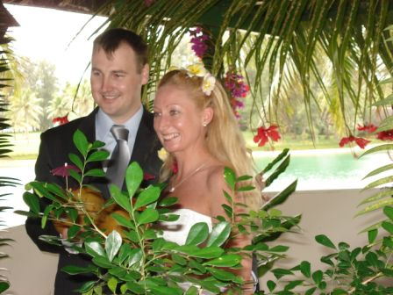

The happy couple Adrian and Joan Hallam

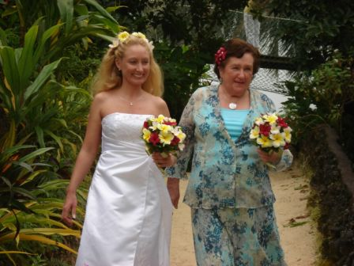

Joan with her proud mother Mollie-Ann Thorp

