A Macinante Australia Publication http://macinante.com Tel Graham 9520-6042

Macinante News

Volume 7 Issue 1 March 2008
FAMILY HAPPENINGS KEEPING in touch

Macinante Web Site
On the Macinante Web site is every past edition of the Macinante News and photos from all picnics back to 1981. Also there is the family tree (updated by Graham Beatson) and memories from all branches of the family back to Salvatore 1848 - 1914 and Anastasia 1858 - 1929. All you need to do is to type into your browser address box “macinante.com”
MM
Macinante Dinner
The Macinante Dinner was held this year at the Bella Vista Italian Restaurant at Parramatta. If you would like attend the next dinner contact Mary Holloway on 9522 8692 GB

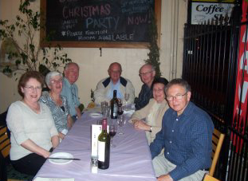
Families enjoy dinner at the Bella Vista Italian Restaurant at Parramatta.
Irish Dancing
In October 2007 Irish Examiners in Australia qualified Rebecca Lewis for her TCRG Certidficate “Irish Dancing Trainer registered in Dublin. This is quite an achievement and folows in the footsteps of her mother Elizabeth Lewis.
Congratulations to Rebecca. GB
Dubai Experience

Highlights in This Issue

1 | Macinante Dinner – December 2007
2 | Dubai Experience
3 | Ann Cuddy Recognition
4 | Twins Once More
5 | Cruises
6 | Adam Carter - Loadmaster
7 | Newlyweds Ray and Moya
8 | Celia Ainsworth - Proud Grandmother
9 | Irish Dancing
Kylie and Rodney Gilbody (Millison Macinante’s Grand daughter) moved to Dubai in 2007 in line with requirements of Rodneys’ job. Rodney and Kylie took the opportunity of the overseas posting to broaden their horizons. Kylies’ mother, Kerry Beatson will be visiting her family next month along with Kylies’ aunty, Noeleen. GB

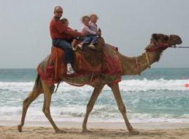

Rodney Gilbody, Megan Sasha and Caitlin camel riding in Dubai.

Ann Cuddy Recognition Ann Cuddy has been awarded in recognised for her valuable contribution to the 2007 Ron Rathborne Local History prize on the 13th October 2007 by the Mayor of the City of Rockdale – John Flowers for the History of Rockdale Places and People. Her works included a biography of Sir Elliott Johnson.
Ann has provided a collection of items making up the scenery and backdrop for the Rockdale Town Hall. The collection can bee seen at Lyndham Hall, Rockdale.
GB
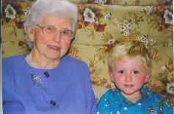
Ann Cuddy with her great grandson Thomas Cuddy

Twins Once More
Mark and Debbie Cuddy (Anastasia Cuddy’s grandson) are expecting twins. Marks’ sisters, Michelle and Melissa Cuddy are twins so on with the tradition. The family is very excited about the coming event. Mark and Debbie currently live in Banks in the ACT. Mark is a specialist in the printing industry and accepted an opportunity to work in the ACT to further develop his skills. GB

Cruises
It appears that Macinante’s are well into cruising, especially on the Princess Line where the drinking age on USA Liners is 21 YOA. Mollie Ann (Daughter of Tory It appears that Macinante’s are well into cruising, Macinante) enjoyed Christmas and New Year cruise on the Sapphire Princess and Margaret Carter (Millison Macinante’s Daughter) cruised to New Caledonia on the Sun Princess in January 2008. GB

Adam Carter - Loadmaster.
Adam Carter has recently become a Loadmaster on the RAAF's new C-17 Globemaster. He completed a three and a half month course with the United States Air Force at Aluts Air Force Base (AFB) Oklahoma. On the 13th of December 2007 there was a small graduation ceremony at the RAAF Amberley Sergeant Mess that his mother and brother flew up to attend. Adam was awarded his Loadmaster brevet, which is similar to a pilot's wing but only one wing. This embellishment signifies that he is aircrew.
Adam is unable to attend this year's picnic as he is currently on the way to the Middle East, his second 'trip' this year. The C-17 Globemaster is Australia's Heavy Lift Military Transport Aircraft and is based at RAAF Base Amberley.
Adam is happy for any of my extended family that
is interested in joining the Defence Force to e-mail him directly (carts44@internode.on.net) with any questions. He feels that after almost 20 years service in both the Army and the Air Force with three different jobs he should be able to give some good advice. AC

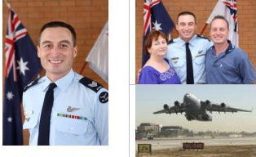
Adam Carter at his presentation at Amberley Air Force Base. Margaret, Adam and David and the gigantic RAAF C-17 Globemaster.
Newlyweds - Ray Sambuco and Moya
The wedding took place on Sunday 18th March 2007 @ 11:00am at The Waterview Restaurant Berowra Waters. The celebrant was an ex squashie from a few years ago who Ray played squash with.
The wedding was attended by mostly family and a few close squash friends who Moya and Ray have acquired over the years (approx 45 people all up).
Moya is one of seven. The only sad part of the day was Mum and Dad and Moya’s Mother were not there to enjoy the day.
After the ceremony everyone moved the great distance of 5 meters to hot and cold seafood buffet meal which lasted about 5 hours. RS
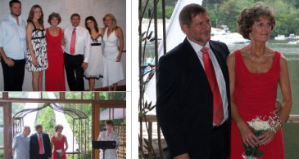
Ray and Moya at their wedding in March 2007.

Celia Ainsworth - Proud Grandmother
Celia is once again a proud grandmother to a bouncing baby boy Brooklyn Michael Ainsworth. Brooklyn was born in May 2007 to parents Scott and Jacki.
Celia’s first grandchild Anastasia Maree was born to Daniel and Lisa. Ann Cuddy could not be more proud of her two great grandchildren one of whom carries her namesake.
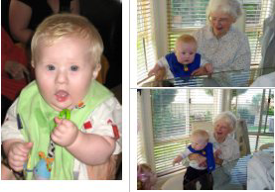 CA
Brooklyn Michael Ainsworth. Ann Cuddy holding Brooklyn and Anastasia in the bottom LH corner.

