A Macinante Australia Publication http://macinante.com Tel Graham 9520-6042

Macinante News

Volume 6 Issue 1 March 2007
FAMILY HAPPENINGS KEEPING in touch

Homeland Research
"At each Macinante picnic Graham Beatson distributes an up-to-date Macinante Family Tree which comprehensively records all the descendants of Salvatore and Anastasia Macinante (most live in Australia).
It would be great if we could find information about Salvatore's brothers and sisters and thereby establish links to those living in Italy. Mick Macinante is trying to get any clues to help in searching the records of Genealogy Societies. If you have any information that might help please contact him on either of the following Email:mickmac@sydney.dialix.com.au or
Phone (02) 9838 0978. MM
Macinante Dinner
Two or three times a year a group of Macinante cousins get together for a dinner in a nice restaurant for lovely dinner and chat. The tradition was started by Mary-Clare and her cousin Celest as a way of catching up. Since the inaugural dinner, the group has grown to include any cousins who may wish to join in. On Saturday, 9th December the dinner was held at Il Pergolota Italian Restaurant at Leichhardt. Five couples enjoyed a lovely Italian Menu with ample Veno. GB
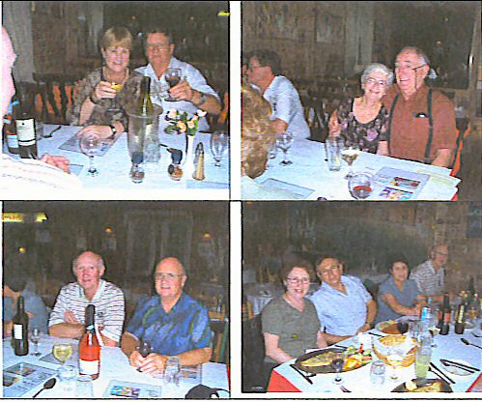
Wedding Bells
Kylie Beatson married Rodney Gilbody on the 5th January Kylie Beatson married Rodney Gilboy on the 5th January 2007 at Elring Winery south of Golburn. The wedding was kept small with 14 immediate family and close friends celebrating the nuptials. The couples three daughters, twins Megan and Sasha and youngest Caitlin attended as flower girls. Kylie ad Rodney honeymooned on Lindamen Island. GB
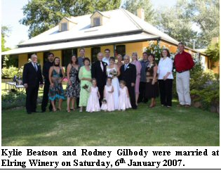

Kylie Beatson and Rodney Gilbody were married at Elring Winery on Saturday, 6th January 2007.

Daniel Holloway

Highlights in This Issue

1 | Macinante Dinner – December 2006
2 | Wedding Bells Kylie Beatson & Rodney Gilbody
3 | Daniel Holloway in London
4 | Justin and Helen Macinante in Germany
5 | Michael and Kath’s Vietnam Adventure
6 | Adeline and Kylee Macinante’s European Tour
7 | Wedding Bells Ray Sambuco and Moya
8 | Peter and Marilyn Pallanza Twin Grandchildren
Dan moved to London in late 2006 and is now working in a hedge fund. Hedge funds are managed funds that use complex mathematically-based trading strategies. When not working Dan is busy traveling Europe. He has been to Scotland, Belgium, Paris, twice to Germany. Daniel is planning trips to Italy, Amsterdam and Denmark in coming months. GH
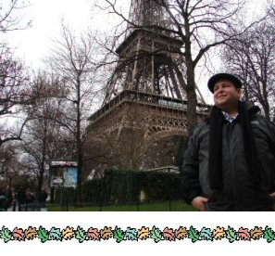

Justin and Helen Macinante
Justin and Helen are living and working in Stuttgart, Germany for the next year or two. Whilst there, they are seeing lots of Europe. GH

Wedding Bells
Moya has finally said yes to Ray Sambuco when he asked for her hand in marriage. They are going to be married on Sunday March 18th, 2007.
It will be a small wedding for immediate family only; Moya is one of seven, so much for a small affair. RS

Michael and Kath’s Vietnam Adventure
In April / May 2006, Mick and Kath Macinante went on a rail tour of Vietnam organised by an Australian Vietnam War veteran. They commenced the journey in Saigon and the Mekong River Delta in the South and travelled by train up the coastline of this long and narrow country boarding on the South China Sea. Mick and Kath visited many historical places like Nha Trang, the ancient capital
Hoi An, Danang and Hue where they enjoyed a cyclo ride to their imperial dinner and visited the famous Citadel palace. After much travel they eventually arrived in the
northern capital Hanoi. From Hanoi they went to the mountain region bordering on China and interacted with some of the hill tribes. A highlight was seeing the tribes tendering to their rice paddies with the use of their buffaloes. The tour was a great experience of a culture and traditions so different from ours. MM
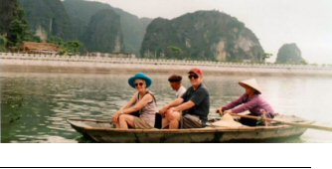

Beatson Family Addition
Shane Beatson, grandson of Millison Beatson is the proud father of a daughter Olivia Patricia Beatson born on the
2nd January 2007.

Shane’s wife Kylie was at a loss for words when their first born, Olivia, arrived four weeks early, especially as they were to be at the wedding of Shane’s sister Kylie and her new husband Rodney the following Saturday. Wedding planning and babies do make strange bedfellows. GB

Shane Beatson holding his new daughter Olivia Beatson born on Tuesday, 2nd January 2007.

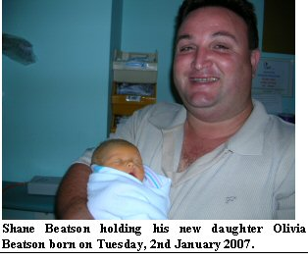
Adeline & Kylee Macinante European Tour.
My grand niece Kylee and I set off for our overseas trip on the 19th June 2006. Our first stop was Athens for two days sightseeing before moving on to the first of three Greek Islands. We were visiting Santorini, a beautiful area and most enjoyable. Next was Naxos, not as spectacular as Santorini but enjoyable. Then to Mykonos with its’ great variety of sandy beaches and entertainment, an absolute hive of activity.

July 1st saw us arriving in Turkey Istanbul Airport then on to our hotel. We spent the next two days sight seeing. It is an amazing place with lots to explore and very friendly people. Next was a short flight from Istanbul to Iznuir where we were met and taken by road to Pamukkale (4hours). From here we had four days touring which included Troy Ephesus and Gallipoli, a wonderful and moving experience. If you haven’t it is a must see. We returned from Istanbul for four days and then on to Venice, with its’ renowned beautiful scenery. Next stop was Salzburg where we attended a great Mozart festival and went on a “Sound of Music” tour to see the areas where the movie was made, including the palace and the church where the wedding took place. We continued on to Innsbruck, a medieval town of various streets surrounded by majestic mountains which I believe is spectacular in winter when snow capped.

Our next flight was to Taormina (Sicily), a beautiful area with magnificent views. The people were friendly and helpful. Most spoke English quite well, fortunately for us. We were taken all around and to lunch and dinner way up in the mountains towards Mount Etna, which continually erupts and at night gives an unusual colourful glow. After five days in, we went through Salerno to Naples. Next day we set off for Montecorvino Pugliano. This meant going back to Salerno then by bus up a narrow, winding road high into the mountains above Salerno, where we met several elderly gentlemen who were very helpful but did not know of the Macinante Family or the old street where the Macinante Villa had been prior to the earthquake, which damaged most of the buildings that had to be demolished. However, they were kind enough to find the postman and an English lady who had lived in the area for fourteen years but no luck, they were unable to help us.

The next day we set off for Roma – so may wonderful sights to see.

From Roma to Florence, with its’ majestic Duomo and Ponte Vecchio, the only bridge left standing after WW2. Next day we set off and found the Fosso (Canal) Macinante. The families originally were millers and the Fosso was used for this purpose. Running parallel to this is via Fosso Macinante with its’ large street sign (Pictured), at the end of which is the Macinante Disco. We felt very proud to think that after all these years we were walking the full length of via Fosso Macinante to get to the disco. Unfortunately the disco was closed. All of these are part of our history. Does anyone have more information regarding our past history?

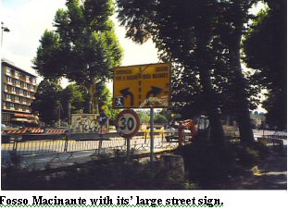
Fosso Macinante with its’ large street sign.

Milan was our next stop. It has an outstanding Gothic Cathedral with masses of statues, spires and pillars. We walked through the Gallery of Victor Emmanuel – very elaborate and expensive. After two days we were on our way north to Lake Como, a very picturesque area.

On to Nice and Monte Carlo. We had a look inside the famous casino. Next was Lourdes, an amazing feeling. The faith of the people, lots of them young, is outstanding.

Next was Paris for the usual sightseeing, then Barcelona, Madrid, Malaga and Seville; all very interesting and busy. Seville and London for six days, Dublin two days then Croatia with its’ with its’ old and new sections, the new section being re-built after WW2. Then Croatia back to Santorini, Athens, Dubai, Singapore and Sydney 26th September 2006. A great holiday which we both thoroughly enjoyed. AM

Kylee and Adeline Macinante on the roof of the outstanding Gothic Cathedral in Milan.

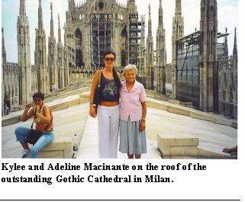
Macinante Family Picnic 2006
Many descendants of the original Salvator and Anastasia Macinante of Salerno / Sicily / Italy enjoyed the fine weather and company of their relatives at the 26th Annual Picnic. The annual gathering has made long lasting friends of perfect strangers. Relative who one never knew existed and all of whom are extremely talented with life stories to tell. GB
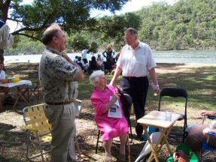
Father Paul Stenhouse chats with Ann Macinante and Paul Sambuco at the 26th Macinante Family Picnic held on the 5th March 2006

Twins Make an Entrance
Anthony Pallanza and his partner Judith had Twins on 21st April 2006. Twin Jacinta Sharon and her brother Harrison Emilio are both doing well. Anthony and Judith also have Jasmyn Emily who was four on the 3rd February 2007. Proud Grandparents - Peter and Marilyn Pallanza.
JP
