A Macinante Australia Publication http://macinante.com Tel Graham 9520-6042

Macinante News

Volume 5 Issue 1 March 2006

FAMILY HAPPENINGS KEEPING INTOUCH

News from ‘The Homeland”.
Mick Macinante was thrilled to receive an e-mail from the homeland. It was from Umberto Macinante of Salerno, Italy. He states that he is the only Macinante living in Salerno. Umberto gave a brief background to his peerage which should link to our ancestors from the homeland. He hopes to come to Australia with his father to meet us all. His e-mail address is <umb.maci@tiscali.it>. GB
Macinante Mid-year Luncheon

On Sunday, 11 September 2005 we held our inaugural Macinante Luncheon at the Engadine RSL. The “all you can eat” menu was superb and at a very good price. However, only sixteen family members attended so it would appear that the interest may not be there. It was planned for six months after the family picnic with the thought that it might attract those who do not like picnics but might prefer the comfort of air conditioning, good seating and clean toilets. As the first Sunday in September was father’s day we opted for the second Sunday. We will discus at the family picnic whether we should hold a mid-year luncheon in 2006. GB
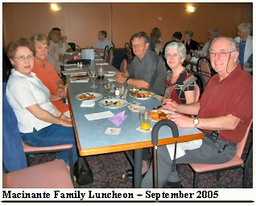

Highlights in This Issue

1 | News from the Homeland.
2 | Macinante Mid-Year luncheon.
3 | Paul Carter Memorial Service.
4 | Anthony (Tony) Macinante
5 | Anthony Macinante’ WW2 Book – Mitchell Library.
6 | Cuddy / Ainsworth Family Addition
7 | Kerri & Gary Hamer - Italian Dinner.

Paul Carter Memorial Service
On Thursday, 29th December 2005, management of State Rail unveiled a plaque in memory of Paul John Carter. Paul was killed near Wollongong Station in the early hours of the 29th December 2004 whilst on his way home from work. Management also arranged a tree planting by his sons, Adam and David in the garden outside the station master’s office. The driver of the vehicle that killed Paul will be sentenced in Wollongong District Court on the 21st March 2006. GB
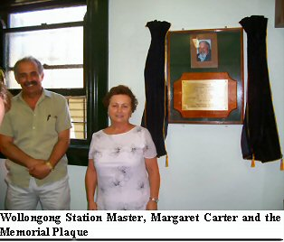
Anthony (Tony) Macinante

Anthony Macinante, son of Amelio and Polly, now in his 91st year, is the patriarch of the Macinante family, having survived his younger brother Alex and sister Mary Cutrupi.
He grew up around Erina and Gosford, left school at 14 years and worked on the farm with his father until it was surrendered to the Bank.
The family moved to a rental house in Drummoyne. He worked in Uncle Edmond’s barber shop at Rose Bay until his father got a start in the Sydney Fruit Markets where they worked together as agents.
In 1935 he got a “Deck Boy” job with the Adelaide Steam Ship Company which led to a career in the Merchant Navy.
On the 27th September 1939, war having been declared, all Merchant Shipping was commandeered by the Navy. His ship the HMAS Westralia (Re-named) eventually became a troop carrier. Anthony joined the army on the 5th July 1940, was assigned to 2/7 Cavalry Regiment (7th Division) and in late December embarked on the Queen Mary for the Middle East.
(Refer to next item) Ann Cuddy.

_________________________________________________________________________________________________________________
Macinante News 03-03-06 1

Anthony Macinante’s WW2 Book – Mitchell Library

Anthony Macinante of Gosford NSW experienced a vast number of events during his service in the Australian Army during WW2. Some of these experiences were sad, some frightening and some lonely. Most of all was that feeling of comradeship. He spoke of much of his war experiences to the Cuddy’s (Ann and Rowe) during family visits. Ann Cuddy, being a member of the ‘Propeller Young Writers’ and ‘Free Expression’ of the ‘Fellowship of Australian Writers’, herself an accomplished writer, felt that his story should not be forgotten and encouraged Tony to write his war service memories for everyone to experience. Fortunately, Tony took notice of Ann Cuddy’s encouragement and under her guidance wrote in long hand, in beautiful articulate handwriting, page by page on foolscap paper, the full story of his WW2 experiences.

This massive task took many months to complete. As each page was completed and the pages built into chapters, Tony would send the scripts to Ann and Rowe for comment. Ann would also send the copies off to my mother Millison Beatson for her interest.

On completion of the full works, the Mitchell Library was approached with regard to their interest in becoming the caretaker of the works and archiving of the full manuscript. Tony’s work is now part of the Mitchell Library where interested parties can view the manuscript and obtain copies if desired. Ann Cuddy purchased, from the Mitchell Library a full copy of Tony’s WW2 memories for the sum of $120.00. She has since passed this copy on to her son, Peter Cuddy, who himself has a strong interest and knowledge of the armed services and service history. To my knowledge, the copy in Peter’s possession is the only copy held by a member of the Macinante family. GB

Cuddy / Ainsworth
Family Addition

Daniel Ainsworth, grandson of Ann Cuddy is the proud father of a daughter Anastasia Maree Ainsworth born on the 17 January 2006.
Daniel’s wife Lisa and daughter are doing fine. Ann Cuddy’s daughter, Cecilia is now a proud grandmother for the first time.
Our sincere congratulations to both Daniel and Lisa. GB

Kerri & Gary Hamer - Italian Dinner.

Kerri and Gary Hamer invited a few interested Macinante’s to her home at Maroubra on Saturday, the 27th August 2005 to sample some genuine Italian recipes as remembered from her younger days. Mary Holloway supplied the antipasto which was absolutely delicious. Kerri cooked Authentic Italian minute steak with authentic tomato sauce over the top. Celest Shirley prepared an egg plant casserole using her mother’s original recipe. Marianne Beatson provided the salad. Desert consisted of puff balls with golden syrup poured over the top and icing sugar. A very enjoyable evening was had by all those who attended. Many thanks to Kerri and Gary. GB
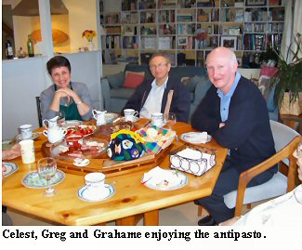
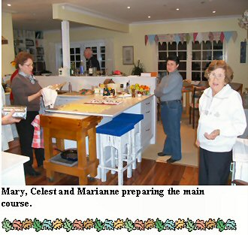

________________________________________________________________________________________________
Macinante News 03/03/06 2

