A Macinante Australia Publication

Macinante News

Volume 2 Issue 1 March 2003
FAMILY HAPPENINGS KEEPING in touch

Annual Picnic 2002
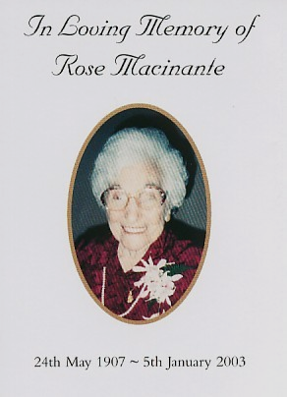
Family, Food, Wine, Beer, and so on. As we all know, the 2002 Picnic was not that well attended due to repeated predictions of bad weather for the day. However, the members of The Family that braved the predictions all had a great day. The usual homemade “goodies” were shared along with the local gossip. Here’s to 2003 being a great success. DG
Picnic 2004 SUNDAY 7th MARCH, 2004
Keep this special day in mind! Note it in your diary, highlight it on your fridge door, punch it into your personal organiser or, graffiti on the back of the “dunny door”. Picnic 2004 heralds 1 year to the 25th Annual Picnic in 2005. A Milestone! Let’s plan now! DG
Mid Year Event
We are still looking to have a mid year event, as several people have shown interest in doing something between picnics. And, we do have some suggestions!

“Sunday Harbour Cruise” ,
A lunchtime or night cruise on The Harbour is always relaxing, especially if the weather is kind. There are several cruises, The Bounty, Captain Cook Cruises, All Occasion Cruises etc. Costs usually start around $55 per head, which includes the cruise and buffet.

“Bounty Theatre Restaurant”, Nowra. A weekend of fun for around $190 for two people. Still top value!
The price includes Motel Accommodation, Theatre Restaurant Show with Dinner and full country breakfast on Sunday morning.

Is anyone interested in these, or other events? See Graham to start the ball rolling. GB
Last Of An Era
Rose Macinante (nee Defina) sadly passed away on Sunday 5th January, 2003. Her funeral was held at St Thomas Catholic Church, Lewisham on Friday 10 January 2003. Later that day Rose was laid to rest in the Defina family vault at Waverly Cemetery.

Rose was born on the 24th May 1907 and was the last remaining member of the Macinante family’s first generation in Australia. Rose married Giocondo (Johnny) Macinante and had three children to him, Terry, Joe and Helen. When her husband Johnny died, Rose was left to raise her three children on her own. However, after some 12 years, Rose married Edmondo Macinante after the death of his wife, Maria.

Rose lived the majority of her life in the Rose Bay and Double Bay areas of Sydney where she was a well-known identity. She lived her life to the full, enduring the hard times and thoroughly enjoying the good times. The family, as a whole, has a plethora of stories and fond memories of Rose that would undoubtedly keep us captivated for hours upon hours.

Rose had an enormous respect and love for the Macinante family and friends. Her knowledge of the family was unsurpassed. You could ask “Auntie Rose” about any one of the family and she could tell you all. She will be sadly missed by all who loved her and cherished her endearing nature. GB/DG
Trip to Italy
Mick and Kath Macinante, Maria and Len Banks, Lynne and Barry Hails visited the Macinante’s ancestral homeland last month. They left Sydney on 3rd January for Italy, taking in Rome, Bologna, Sassuolo-Bologna, Venice, San Marino, Florence, Siena, San Gimignano, Pisa, Assisi, Sorrento, Pompei, Capri, La Costiera, and Amalfitana. We look forward to hearing of their adventures.

Highlights In This Issue
1 | Annual Picnic 2002 and 2004, Mid Year Event.
2 | Last Of An Era – ROSE MACINIANTE
2 | Special Interest and Events. Trip to Italy.
3 | Food Craft and Family Success Stories
4 | Honour Role – GRAHAM BEATSON

Greg and Mary Holloway plan to travel Italy later this year. If any of the family is interested or can provide some trips, then I am sure that this would be very much appreciated. GB

Food Craft
C
ANDIDO’S ANISEED BARS

Ingredients for 72 bars
4lbs Sugar
2 ladle Glucose
2 cups Water
Colour to suite
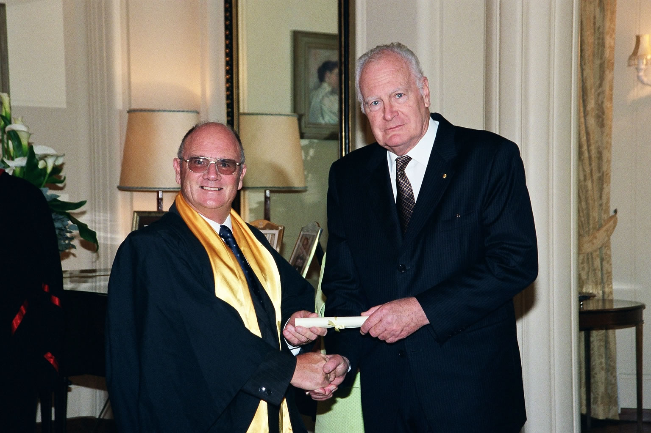
1dtsp Oil of Aniseed

Method
Boil all ingredients together to 280 degrees. Pour onto slab and let cool.
Cut cooled slab into bars each ³/₄inch x 4inches
You should get around 6 dozen bars. CM

Heritage: Candido (Papa) Macinante

Candido was a hairdresser and operated his own salon in George Street, Broadway, Sydney. Whilst Candido worked in the Broadway salon, his wife Olivia ran the Hurstville Primary School tuck-shop from the front of their home, which was opposite the school at 51 Forrest Road, Hurstville. Ah, the good old days!

Achievement !
Kelli Ann Dugdale, daughter of Maria Dugdale (nee Macinante), graduated from the University of New England from a Bachelor of Commerce, majoring in Accounting and Finance. Kelli Ann then went on to attend the College of Law, from which she graduated in July 2002. She has been admitted to both the Supreme Court and the High Court. Kelli Ann is now a practicing solicitor, specialising in family law and is with the respected law firm of Fishburn–Watson-O’Brien at Coffs Harbour. Congratulations !! DG
86th Birthday !
Rowe Cuddy will celebrate his 86th birthday on the 16th March 2003. We wish Rowe a very happy birthday and a hearty celebration with his family and friends. GB
1st Grandchild
Peter and Marilyn Polanza have their first grandchild, a grand-daughter born the first week of February 2003. Heart-felt congratulations to them! There is always the old saying, “If I had known my grandchildren were this much fun I would have had them first!” GB
Big Sister !
Millison Beatson has moved her place of residence. She is now residing at the BIG SISTER HOSTEL at 2C Karimbla Road, Miranda. The contact number for BSH is 02 9524 1184. GB

Honour Role
GRAHAM BEATSON
Canberra, Tuesday 12 November, 2002 Graham Beatson was awarded a College of Fellows fellowship of the Safety Institute of Australia by His Excellency the Governor-General of Australia, The Rt Rev Dr Peter Hollingsworth. Graham and Marianne both attended Government House, “Yarralumla”, Canberra, ACT for the award. After the awards, morning tea was provided and a chance to meet with their Excellencies the Governor-General and Mrs Ann Hollingsworth and to inspect “Yarralumla” and its manicured gardens. DG
Success Stories
Success from your efforts during life is satisfaction for your soul. Recent “Macinante” successes have been;

Joan Thorp (granddaughter of Tory Macinante from Wollongong) set up her own music writing and publishing company in 2002. Thorp Music now distributes to all schools in Australia. Joan also has her own band named “Abracadabra”. Her mum, Mollie-Anne, fills the orders for sheet music from her home in Tweed Heads. Email address is sales@thorpmusic.com
CONGRATULATIONS !! GB
Holiday Accommodation
If you are looking for a holiday on the Gold Coast there is no better value for money than The Beatson's two-bedroom unit on the beach at Tugun. $220.00 per week plus cleaning $49.50 or $280.00 school holidays. Unfortunately Christmas school holidays are booked out. Contact the Gold Coast Agent, Andrew Reynolds on (07) 5534 1888. GB
http://macinante.com
Mick Macinante’s tremendous effort into organising the Macinante Family Website has paid off. What a wealth of information! DG
Contact Info
ANNUAL PICNIC ARRANGEMENTS
Graham Beatson - Director
Ph Hm: 9520 6042 Mob: 0418 650 334
Email: completesafeserv@bigpond.com

NEWS LETTER ITEMS & FAMILY RECIPIES
Derek Gentle – Editor & Publisher
Ph Hm: 02 9525 9881 Mob: 0422 230 488
Email: gentled@acay.com.au

