A Macinante Australia Publication http://macinante.com Tel Graham (02) 9520-6042

Macinante News

Volume 11 Issue 1 March 2012
FAMILY HAPPENINGS KEEPING in touch

Macinante Web Site
Mick Macinante continually updates the Macinante Web site (http://macinante.com) with family happenings and events. If you have any items that you feel you would like to have included on the web site, send them to Michael on mickmac@sydney.dialix.com.au GB

2012 Annual Luncheon
In 2012 we will hold the Macinante annual luncheon at the Bankstown Sports club but a little later than usual due to social commitments. It will be held on the 3rd Sunday, which will be the 18th March 2012. Last year we had a special guest Luigi Macinante and his wife from Italy. They were touring Australia, discovered the Macinante WEB Site and decided that they would drop in and meet fellow Macinante’s. All those in attendance appreciated their visit. GB

Deaths
Millison Lucy Beatson (nee Macinante and daughter of Candido) died on the 24th May 2012 in Lark Ellen Nursing Home at Jannali aged 90. GB

Teresa May Macinante died on the 29th June 2011 at Calvary Hospital, Kogarah aged 94. Teresa was born on the 30 May 1917 and was married to Joseph Macinante the second eldest son of Candido. MH

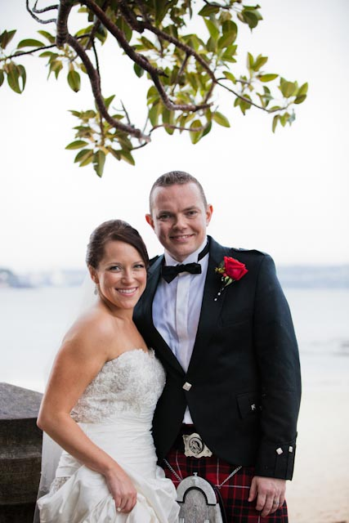

Weddings
Naomi, daughter of Greg and Mary Clare Holloway, celebrated her marriage to Fergus Stevens on Sunday 11th December at Cardinal Ceretti Chapel, Manly. This was followed by dinner at Sergeants Mess, Chowder Bay. For their honeymoon Naomi and Fergus traveled to Thailand and Bhutan.” GH
Highlights in This Issue
1 | Macinante Web Site
2 | 2012 Family Picnic
3 | Deaths
4 | Naomi and Fergus Stevens Wedding
5 | Norfolk Island
6 | Story of the Macinante Picnic

Vision Printing Services
Mark Cuddy, great grandson of Candido, took charge of
Vision Printing Services Engadine in January 2012. For
all your printing needs phone Mark on 9520 4507 or email your job visionprinting@bigpond.com directly to his office for fast response and attention. GB

Norfolk Island
Margaret Mostyn (Granddaughter of Candido Macinante) and her husband Frank spent several months on Norfolk Island in 2011. Frank is an Anglican Minister and worked during this time as the Islands Minister at the Church of England St Barnabas Church and also the All Saints Chappell at Kingston. Margaret’s brothers Graham and Brian visited in July 2011, as did her eldest son Adam Carter. GB
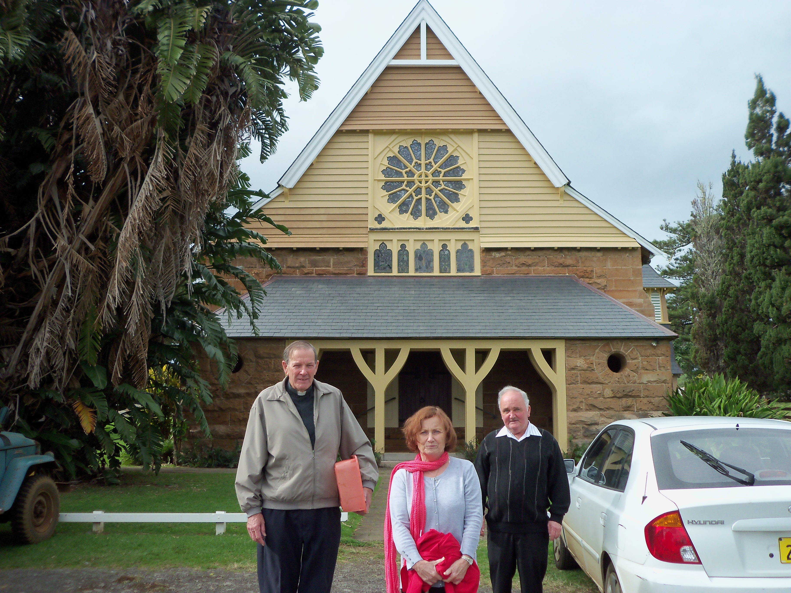
Frank Mostyn with his wife Margaret with Brian Beatson in front of the St Barnabas Church of England Church - Norfolk Island.

Story of the Macinante Picnic

The inaugural Macinante Picnic was held on the first Sunday of February 1981 at Cattle Duffers Flat, Picnic Point, Sydney. This picnic was the idea of Graham Beatson in order to have a gathering of all of his cousins and their children for an annual get-to-gether. Thus the first picnic was isolated to the descendants of Candido Macinante only. The word went out on the Macinante grapevine and Electra Polanza heard the news that a Macinante Picnic was on. The next year, 1982 first migrant cousin’s attended with their families and the group swelled to close on 100 in attendance.

In 1993 family members put the proposal to move the date to the first Sunday in March of each year, as February was a bit too hot. In 2009 the gathering moved to the Bankstown Sport Club, due to less work and more comfort.

Michael Macinante took on the role of transferring all Macinante material including Macinante Picnic photographs to computer and developed the Macinante Web Site. Michael has expended the site over the years to include a vast website of information including personal stories and eulogies.
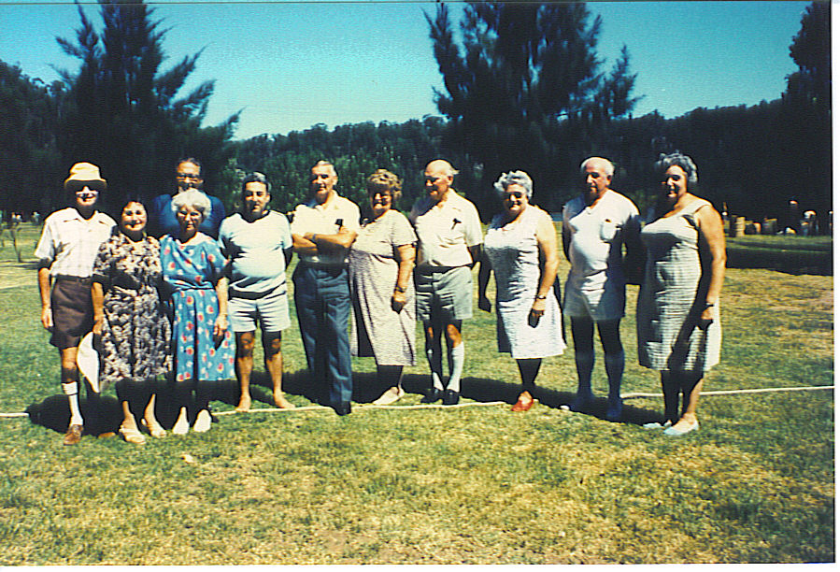
First Australian Cousin’s 1981
This proved to be a very interesting time as suddenly cousin’s who had not seen each other for a number of years and their children met family members who were totally unknown to each other. Electra Pollanza commenced an attendance book and organised photographs to be taken of cousin groups.

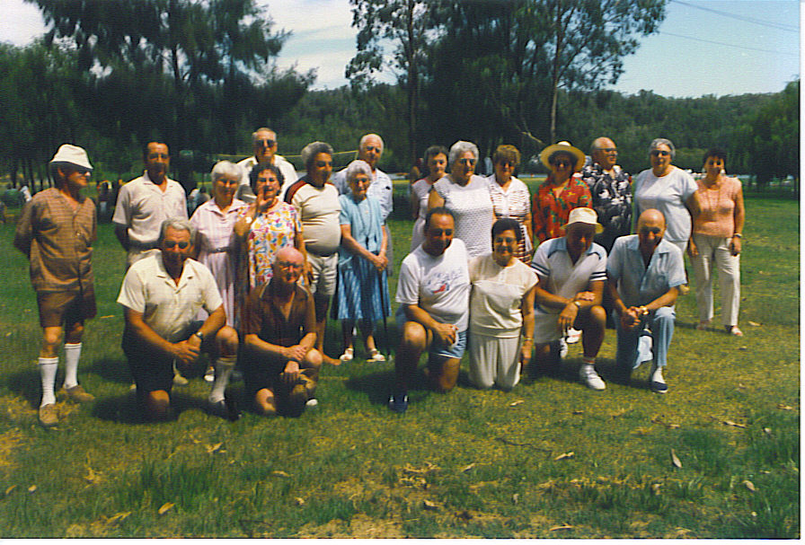
First Australian Cousin’s 1986
Graham Beatson developed the first family tree and then Ray Sambuco improved on this when he developed a computer version as an exercise to learn the new excel program that had just been introduced by Microsoft.
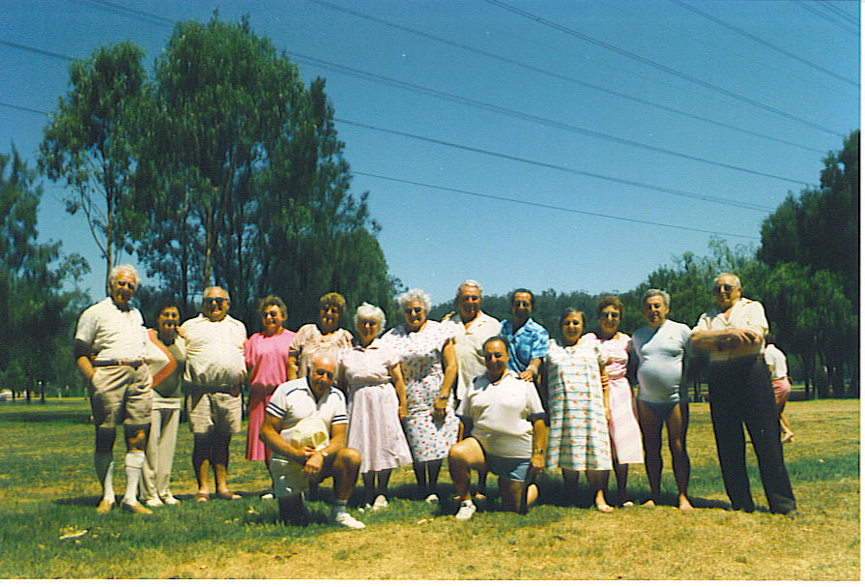
First Australian Cousin’s 1987
Derek Gentle came up with the idea of writing a Macinante newsletter. He was the edited until his business interests took precedence and he handed the role over to Greg Holloway. Greg later moved the role to myself, Graham Beatson. The format remains as originally designed by Derek. GB.

